Design and Simulation of Microstrip Patch Antenna Using CST

# I. Table of Contents:

Contents:

I. Table of Contents: 1

II. Contribution Matrix: 2

III. Abstract: 2

IV. Introduction: 2

V. Literature Review: 3

VI. Methodology: 4

VII. Simulation Results: 6

VIII. Interpretation of Results: 10

IX. Application of the Design: 10

X. Shortcomings/Drawbacks of the Design: 11

XI. Conclusion: 11

XII. References: 11

# II. Contribution Matrix:

|  |  |  |  |  |  |
| --- | --- | --- | --- | --- | --- |
| Group Member | Research on Antenna Type | CST Design Contribution | Result Analysis Contribution | Project Report Writing | Presentation (PPT) Preparation |
| 202116006 |  | Checkmark with solid fill | Checkmark with solid fill |  |  |
| 202116023 | Checkmark with solid fill | Checkmark with solid fill |  | Checkmark with solid fill |  |
| 202116045 | Checkmark with solid fill |  | Checkmark with solid fill | Checkmark with solid fill | Checkmark with solid fill |
| 201916001 | Checkmark with solid fill | Checkmark with solid fill |  |  | Checkmark with solid fill |
| 202116135 | Checkmark with solid fill |  | Checkmark with solid fill |  | Checkmark with solid fill |

# III. Abstract:

This project report presents the design and simulation of a microstrip patch antenna using CST Microwave Studio. The primary focus was to analyze the antenna's performance through the visualization of 2D and 3D radiation patterns and to assess various parameters critical to its functionality. Key metrics such as reflection coefficient, S-parameters, Voltage Standing Wave Ratio (VSWR), resonant frequency, and electric field distribution were graphically represented and analyzed. The far-field radiation patterns were also visualized, providing insights into the antenna's directional properties and overall performance. The results from these simulations offer a comprehensive understanding of the antenna's characteristics, highlighting its potential for various communication applications.

# IV. Introduction:

The rapid development of wireless communication systems, particularly the transition to 5G networks, has placed stringent requirements on antenna design, including compact size, high efficiency, and the ability to operate at millimeter-wave frequencies. Microstrip patch antennas have emerged as one of the most suitable antenna types for these applications due to their low profile, lightweight, ease of fabrication, and ability to be integrated into planar structures such as printed circuit boards (PCBs). These characteristics make them ideal for modern communication systems that demand efficient, high-frequency performance while minimizing the physical footprint.

A microstrip patch antenna typically consists of a conducting patch on one side of a dielectric substrate, with a ground plane on the other. The performance of the antenna is strongly influenced by the dielectric constant of the substrate, the thickness of the substrate, and the dimensions of the patch. For this design, Rogers RT5880 was selected as the substrate material due to its favorable dielectric constant of *ϵr* =2.2 and low loss tangent, both of which are essential for maintaining signal integrity at high frequencies. The height of the substrate was set to 0.254 mm to balance size and performance.

The resonant frequency *fr* of a rectangular microstrip patch antenna is determined by the width of the patch, which is calculated using the following formula:

where *c* is the speed of light, *W* is the width of the patch, and *ϵr* is the dielectric constant of the substrate.

Additionally, the length of the patch is an important parameter, as it influences the antenna's resonant frequency and radiation characteristics. To accurately determine the length, it is necessary to account for the fringing effects that occur at the edges of the patch. These effects are represented by the effective dielectric constant *ϵeff* which can be calculated using the formula:

where *h* is the height of the substrate and *W* is the width of the patch. The fringing extension *ΔL* can then be determined by:

The effective length, *Leff* of the patch, accounting for these fringing fields, is given by:

Finally, the actual length *L* of the patch is computed by subtracting the fringing extension from the effective length:

These calculated dimensions allow the microstrip patch antenna to be optimized for operation at the target frequency of 33 GHz. This frequency is within the millimeter-wave range, which is critical for 5G applications, where high data rates, low latency, and efficient spectrum usage are required.

The design of microstrip patch antennas for such high-frequency applications involves trade-offs between size, bandwidth, and efficiency. Proper substrate selection and careful calculation of the antenna dimensions are essential for ensuring optimal performance, particularly in terms of impedance matching, radiation efficiency, and overall antenna gain. This project aims to demonstrate the design process for a 5G-compatible antenna operating at 33 GHz, providing a compact, efficient solution for next-generation communication systems.

# V. Literature Review:

Microstrip patch antennas are widely used in modern communication systems, especially for millimeter-wave (mmWave) applications such as 5G, due to their compact size, low cost, and ease of integration [1]. The basic structure of a microstrip antenna consists of a metallic patch on a dielectric substrate with a ground plane underneath, making it an effective choice for high-frequency applications. Balanis [1] emphasizes that substrate properties, particularly the dielectric constant, play a significant role in determining the performance, bandwidth, and efficiency of the antenna. Low dielectric constant substrates like Rogers RT5880, with *ϵr* =2.2, are ideal for millimeter-wave applications due to their low loss and high performance [2].

As 5G networks demand higher operating frequencies, such as 33 GHz, the design of microstrip patch antennas faces challenges like maintaining radiation efficiency and bandwidth in smaller physical dimensions. According to Liu et al. [3], optimizing parameters like patch dimensions and feed techniques is essential to achieve high performance in 5G systems. Additionally, researchers have explored different patch geometries and substrate materials to improve antenna gain and minimize surface wave losses [4].

Several studies highlight the importance of choosing high-performance substrates like Rogers RT5880 for millimeter-wave antennas. This substrate offers low loss and improved impedance matching, making it a popular choice for 5G antennas [5], [6]. Furthermore, optimization techniques such as the incorporation of parasitic elements or tuning the feed structure have been shown to enhance radiation characteristics and improve bandwidth [7].

In summary, the design of microstrip patch antennas for millimeter-wave applications involves balancing trade-offs between size, gain, efficiency, and bandwidth. Recent research emphasizes the critical role of substrate selection and geometric optimization in achieving high performance for 5G communication systems [6], [8].

# VI. Methodology:

a. Flow chart

The following flowchart provides a comprehensive overview of the steps involved in our project, illustrating the design process in detail.

Analysis of Simulation Results

Simulation of Antenna Using CST

Antenna Design  
Analytical Calculation

Defining Project  
Specification

Figure 1: Flowchart

The details pertaining to each block can be elaborated as follows.

1. Define Specifications: This foundational block sets the parameters and objectives of the design process. It entails the precise definition of key operational metrics, including the target operating frequency of 33 GHz, which is critical for 5G mmWave applications. In this phase, meticulous selection of the substrate material (Rogers RT5880, εr = 2.2), substrate thickness (typically 0.787 mm) is undertaken. Establishing these specifications is paramount to guiding the subsequent phases of the design and ensuring the antenna's performance meets industry standards.
2. Antenna Design (Analytical Calculations): In this block, the antenna’s structure is conceptualized based on the defined specifications. Analytical calculations are employed to determine the optimal dimensions of the microstrip patch antenna, taking into account parameters such as the wavelength at 33 GHz and the dielectric constant of the substrate. These calculations yield the effective length and width of the patch, the feed line location, and the ground plane dimensions. Special attention is given to fringing fields and their influence on the effective dielectric constant and resonant frequency.
3. Simulation Using CST: The designed antenna is subjected to a full-wave electromagnetic simulation to evaluate its behavior under operational conditions. The simulation involves setting boundary conditions, defining the excitation source for the patch, and establishing a frequency sweep to observe performance over a range of frequencies around 33 GHz. Key performance metrics such as S-parameters (S11), VSWR, gain, and the radiation pattern are calculated.
4. Analysis of the Results: The focus is on interpreting key performance indicators—ensuring the reflection coefficient (S11) is below the required threshold (typically -10 dB), confirming VSWR values are within acceptable limits, and assessing the antenna’s gain and radiation efficiency. The results are compared against the initial design specifications to identify any deviations in the resonant frequency, impedance matching, or radiation characteristics.

b. Design Parameters

Here are the CST design parameters. The frequency band is set for 33 GHz, and the antenna dimensions are optimized for compactness and flexibility to ensure effective performance across various applications. Fig 2 shows the schematic of the antenna in CST.

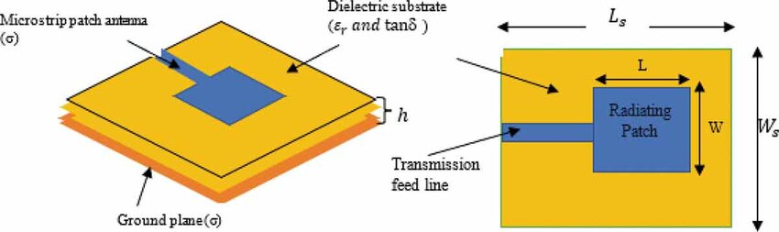 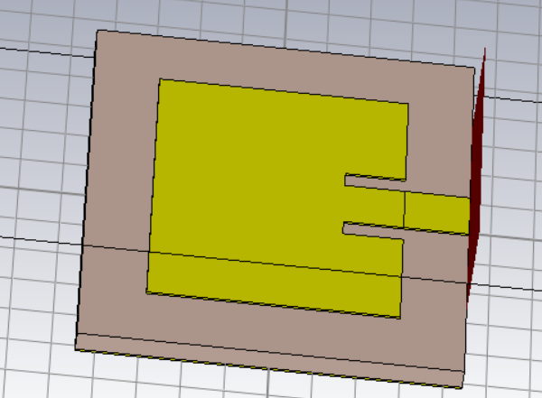

Figure 2: Microstrip Patch Antenna Configurations. CST schematic- right

Table 1 presents the parameter list of this design, outlining dimensions of the microstrip patch antenna.

|  |  |  |  |
| --- | --- | --- | --- |
| Parameter List | Value | Parameter List | Value |
| antx | 3.593 | sbh | 0.254 |
| anty | 2.9214 | sbx | 5.117 |
| inx | 0.2 | sby | 4.454 |
| iny | 0.7 | tx | 0.61 |

Table 1: Design Parameters of Microstrip Patch Antenna

Here,

* Width of substrate, Ws=sbx, Length of substrate, Ls=sby. inx and iny are inset width and height respectively.
* Length of Patch, L=anty, Width of Patch, W=antx
* Length of transmission line is tx.

# VII. Simulation Results:

In this section, we present the key simulation outputs for the designed microstrip patch antenna operating at 33 GHz. The results cover the reflection coefficient (S11), Voltage Standing Wave Ratio (VSWR), far-field radiation patterns, and electric field, magnetic field distributions.

1. S11 Parameter:

Figure 3 shows the reflection coefficient (S11) as a function of frequency. The minimum value of S11 is -23 dB at 33 GHz, indicating excellent impedance matching at the operating frequency. This low reflection confirms efficient power transfer from the transmission line to the antenna.

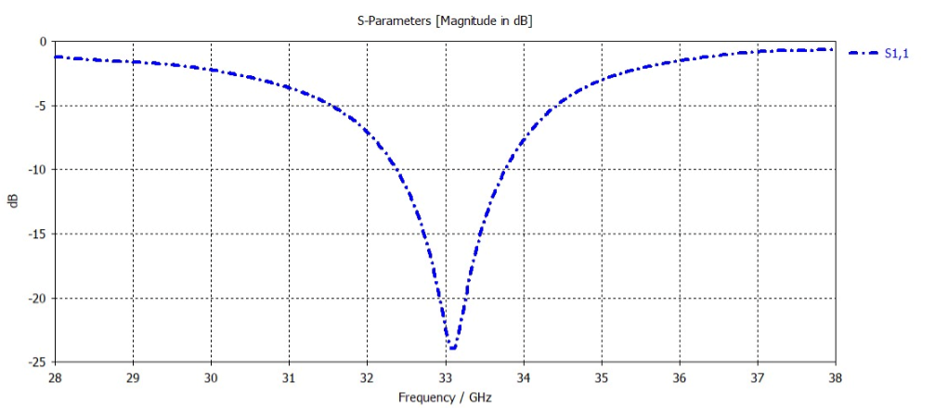

Figure 3: S11 Parameter vs Frequency.

2. VSWR:

Figure 4 presents the VSWR graph. The VSWR reaches a minimum value close to 1 at the resonance frequency of 33 GHz, validating that the antenna is well-matched to the feed line with minimal signal reflection.

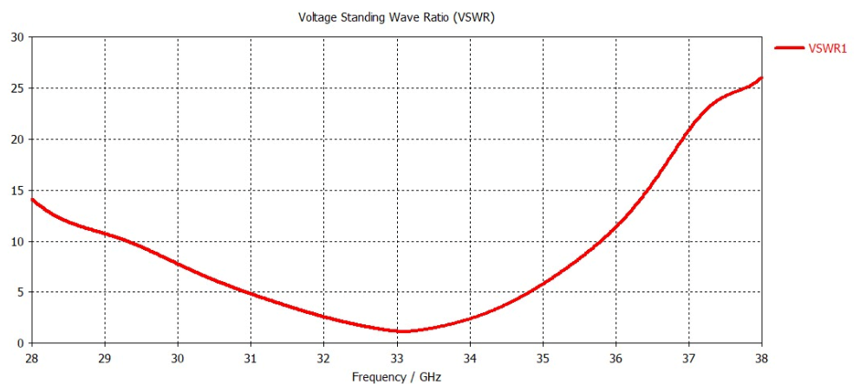

Figure 4: VSWR vs Frequency.

3. Reflection Coefficient:

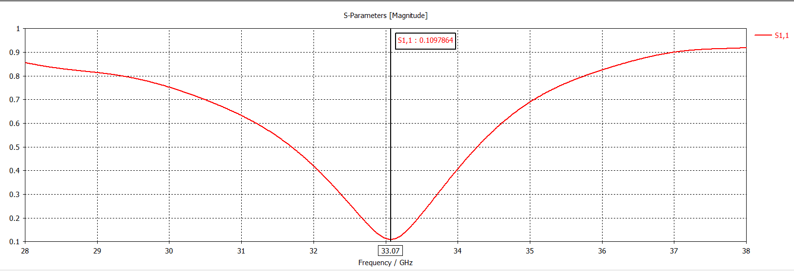Figure 5 shows the reflection coefficient of 0.1067864 for the microstrip patch antenna which indicates minimal signal reflection at the feed point, showcasing efficient impedance matching. This low reflection ensures that the majority of the input power is radiated effectively, contributing to the antenna's overall performance at the target frequency.

Figure 5: Reflection Coefficient of the antenna

4. Far-Field Radiation Pattern:

Figure 6 and Figure 7 show the far-field radiation patterns. In the polar plot (Figure 6), the main lobe magnitude is 6.63 dBi with a main lobe direction of 4 degrees. The side lobe level is -15 dB, ensuring minimal interference. Figure 7 shows the directivity in a 2D view, where the red areas indicate maximum radiation intensity.

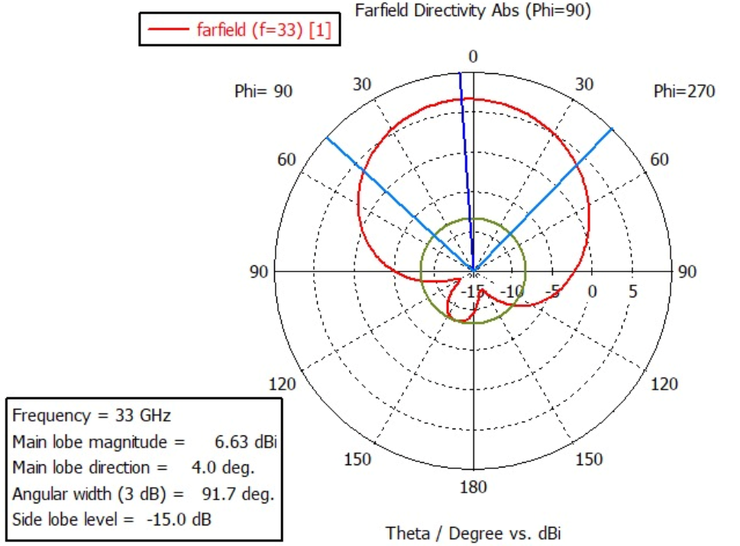

Figure 6: Polar plot of Far-Field Directivity (Phi = 90 degrees).

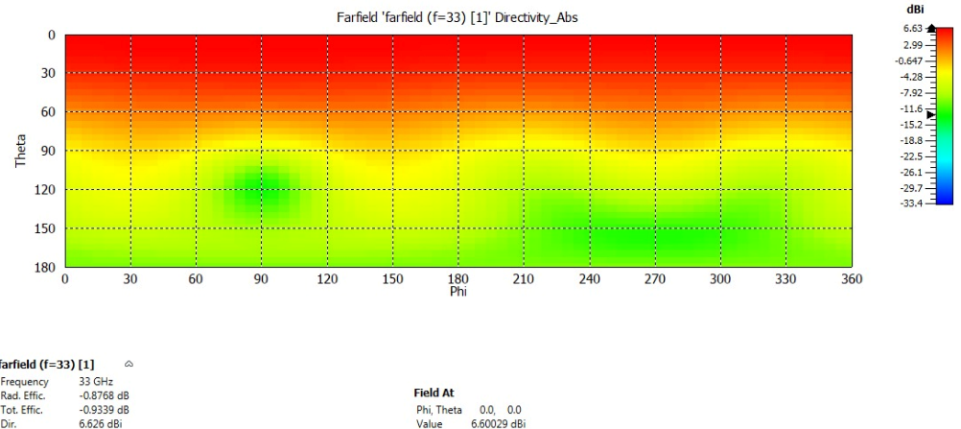  
Figure 7: 2D Far-Field Directivity Pattern.

5. Electric Field Distribution:

Figure 8 depicts the electric field distribution on the patch surface at 33 GHz. The maximum E-field intensity is concentrated along the edges of the patch, confirming strong radiation from the antenna at the desired frequency.

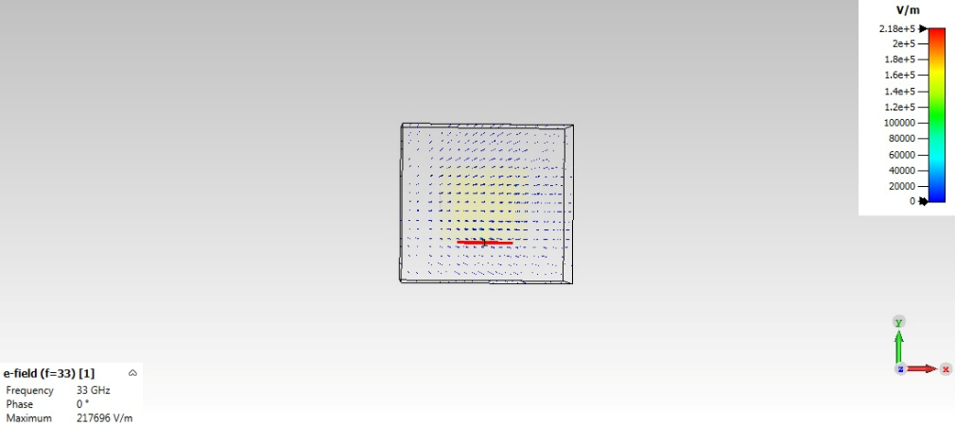

Figure 8: Electric Field Distribution.

6. Magnetic Field Distribution:

Figure 9 depicts the electric field distribution on the patch surface at 33 GHz. The maximum H-field is concentrated along the edges of the patch.

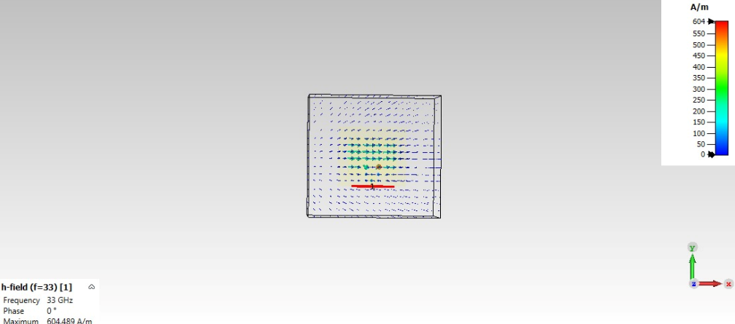

Figure 9: Magnetic Field Distribution.

# VIII. Interpretation of Results:

The simulation results indicate that the microstrip patch antenna at 33 GHz exhibits highly directional radiation, with a main lobe magnitude of 6.63 dBi and minimal sidelobe levels of -15 dB. This suggests strong signal focus and reduced interference, essential for 5G communications. The S11 parameter, with a sharp dip around -23 dB, confirms excellent impedance matching at the operating frequency, ensuring efficient power transfer and minimal reflection. The VSWR, peaking close to 1 at the resonance frequency, further validates efficient signal transmission, while the wide bandwidth coverage with a VSWR below 2 highlights the antenna's operational flexibility. The far-field directivity reveals a well-focused beam with an angular width of 91.7 degrees, balancing gain with area coverage, making the antenna suitable for scenarios requiring broad signal reach without frequent adjustments.

The far-field directivity plot at 33 GHz demonstrates a main lobe magnitude of 6.63 dBi with a main lobe direction of 4 degrees, indicating that the antenna has a well-defined directional radiation pattern. The side lobe level of -15 dB confirms minimal signal loss in unwanted directions, ensuring a strong and focused transmission, ideal for 5G applications where directed communication is key. The angular width of the main lobe is approximately 91.7 degrees, which suggests that the antenna provides a moderate beamwidth, offering a good balance between gain and coverage area.

The 2D and 3D radiation patterns reveal that the radiation is concentrated along the primary axis, with strong emission in the broadside direction (along the z-axis). This focused radiation is essential for applications requiring high directionality and reduced interference. The gradual color transition in the far-field plot highlights the energy distribution, with the red regions representing areas of maximum radiation intensity. Additionally, the electric field distribution shows strong radiation along the patch edges, which is critical for effective signal propagation. With a maximum E-field intensity of 217,696 V/m, the antenna demonstrates substantial radiative capability. The radiation efficiency, near 100%, and minimal losses of -0.87 dB affirm the suitability of RT5880 as a low-loss substrate, optimizing the overall performance for high-frequency applications.

The results confirm that the antenna is well-optimized for 33 GHz, offering a strong and focused far-field radiation pattern, minimal reflection, and excellent overall performance.

# IX. Application of the Design:

The designed microstrip antenna serves a wide range of applications across various fields.

1. 5G mm Wave Communication: Supports high-speed, low-latency data transmission in 5G networks.
2. Mobile Devices: Suitable for integration into smartphones and tablets for faster wireless connectivity.
3. Base Stations: Enhances network capacity and coverage in 5G base station infrastructure.
4. IoT Devices: Provides efficient communication for smart devices and sensors in IoT systems.
5. AR/VR Applications: Enables low-latency, high-bandwidth data transfer for immersive AR/VR experiences.
6. Autonomous Vehicles: Facilitates real-time communication for vehicle-to-vehicle (V2V) and vehicle-to-infrastructure (V2I) systems.

# X. Shortcomings/Drawbacks of the Design:

The main shortcoming of the antenna design, with the S-parameter (S11) at 33.07 GHz instead of the target 33 GHz, is the slight frequency shift, which can cause impedance mismatch and reduced efficiency at the desired frequency. Although the reflection coefficient remains below -10 dB, indicating reasonable performance, the shift suggests the antenna's gain, directivity, and overall effectiveness may be compromised at 33 GHz, potentially limiting bandwidth coverage and reducing its suitability for 5G mmWave applications. Additionally, the design could be sensitive to fabrication tolerances and material variations, which might exacerbate detuning in practical implementations. The RT5880 substrate, while offering low loss and stable dielectric properties, has its own drawbacks, including higher cost, low thermal conductivity that could lead to heat management issues, and limited mechanical flexibility, making it less ideal for cost-sensitive or physically demanding environments.

# XI. Conclusion:

This project successfully designed and simulated a microstrip patch antenna for 5G applications at 33 GHz using CST Microwave Studio. The process involved detailed calculations and simulations to ensure optimal performance, including key metrics like S-parameters and VSWR. The antenna demonstrated good performance within the target range. The design process showcased the importance of balancing size, efficiency, and performance for high-frequency applications. Despite some limitations, the antenna holds great promise for use in 5G networks and other advanced technologies.

# XII. References:

1. C. A. Balanis, *Antenna Theory: Analysis and Design*, 4th ed., Hoboken, NJ, USA: John Wiley & Sons, 2016.
2. Rogers Corporation, *RT/duroid® 5880 High-Frequency Laminates* [Data sheet], 2020. [Online]. Available: [https://www.rogerscorp.com](https://www.rogerscorp.com/)
3. Y. Liu, H. Zhang, and X. Yin, "Design of a millimeter-wave microstrip patch antenna for 5G applications," *IEEE Trans. Antennas Propag.*, vol. 68, no. 2, pp. 1214-1217, Feb. 2020.
4. G. Kumar and K. P. Ray, *Broadband Microstrip Antennas*, Norwood, MA, USA: Artech House, 2003.
5. S. Mishra, "High-performance substrates for millimeter-wave antennas," *J. Microw. Tech.*, vol. 54, no. 6, pp. 300-310, Jun. 2018.
6. M. Alibakhshikenari et al., "A comprehensive survey on microstrip patch antennas for millimeter-wave applications," *IEEE Access*, vol. 9, pp. 135324-135355, 2021.
7. K. L. Wong, *Compact and Broadband Microstrip Antennas*, Hoboken, NJ, USA: John Wiley & Sons, 2002.
8. R. Garg, P. Bhartia, I. Bahl, and A. Ittipiboon, *Microstrip Antenna Design Handbook*, Norwood, MA, USA: Artech House, 2001.